**Introduction to Computer Science**

**PROGRAMMING PROJECT**

**DUE DATE:** Tuesday , November 28, 2017. (anytime till the labs are open)

**IMPORTANT**

* Your code should be properly commented
* Variable and function names should be meaningful and without abbreviations
* Your program should be user friendly
* Deduction of marks for messy and confusing code
* **Plagiarism will not be tolerated**. It will result in a straight F in the course and forwarded to DC committee, who might award 5 F’s in all courses you are taking.

You have to submit a complete working system, along with the source code and a readme file that tells us how to use your software.

**Bonus will be marked only if the core functionalities are complete.**

The weightage is 10%. If the students implement a text based game (rather than graphical), then the maximum marks that they can get is 6.

**DETAILS OF THE GAMES**

Bejeweled Blitz

The board contains 8x8 jewels. There can be 5 different jewels. Each of different color and shape. This game is played using a mouse, but you will use keyboard.

Play this game at: <https://apps.facebook.com/bejeweledblitz/>

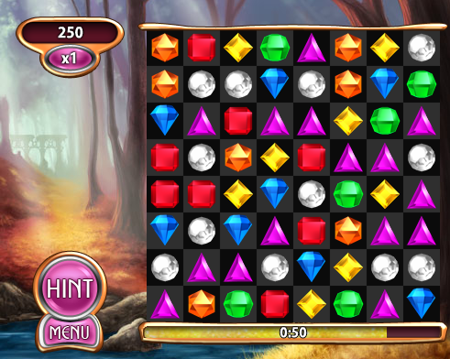

Use some marker to indicate where you are on the board. You can move up,down,left or right using cursor keys. To select press enter.

You have to maintain scores and time

Shapes can be as simple as you like. The board is filled randomly using rand.

The tutorial is given below:

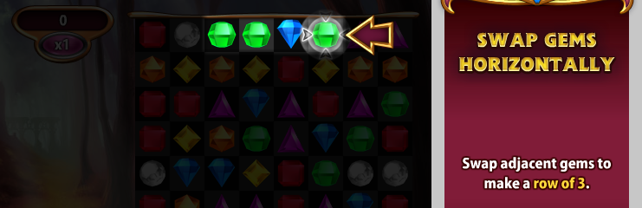

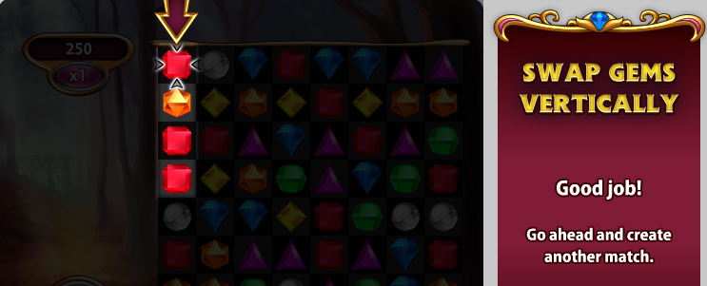

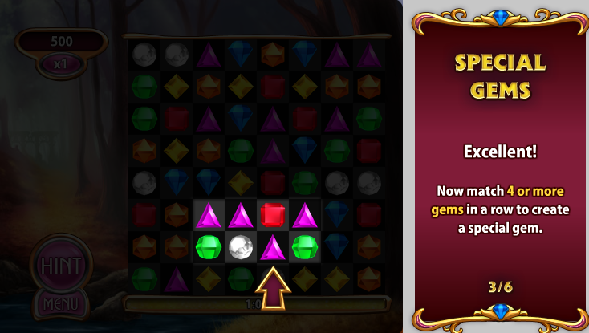

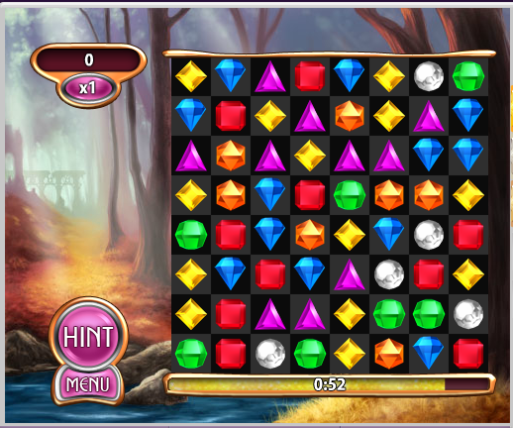

Move this shape down to get the special gem.

The special gem looks like this!!!!

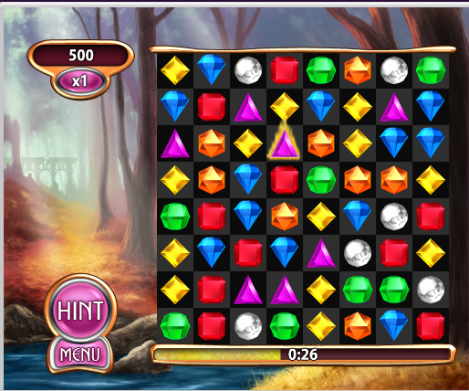

The special gem can explode when you get 3 or more gems in a straight line

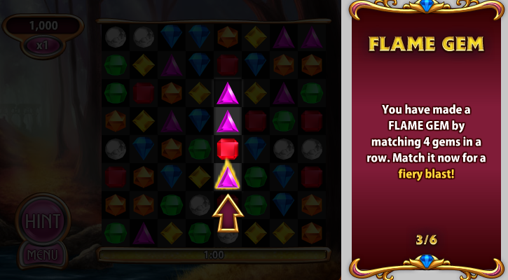

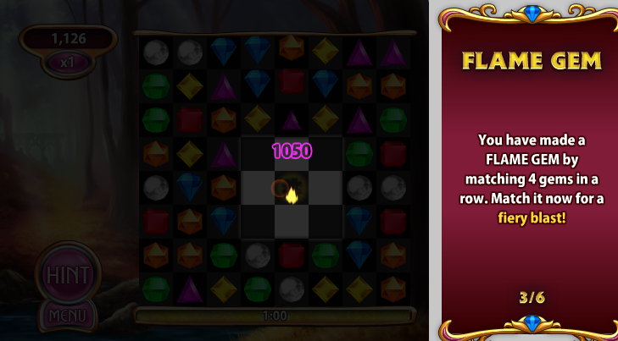

Explode radius



When you combine 5 gems at the elbow, you get a destroyer gem.

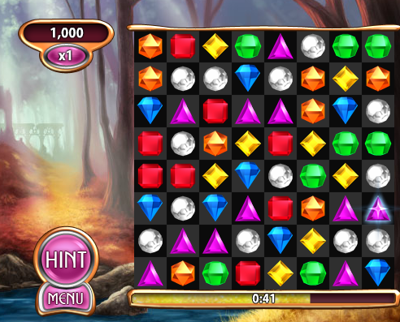

This is how the destroyer gem looks like.

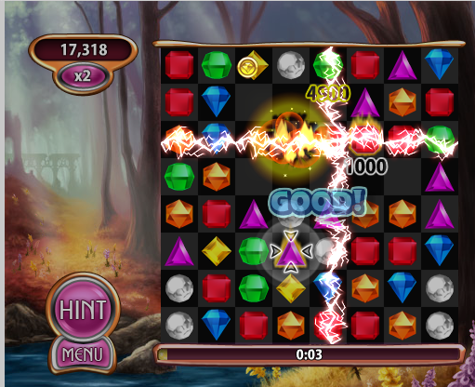

And this is how it explodes